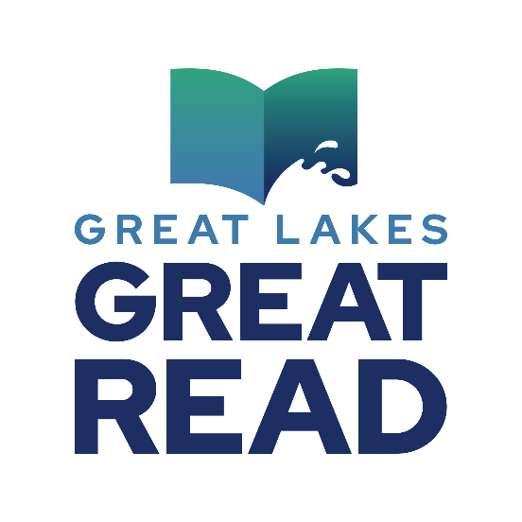

**Great Lakes Naming Card**

Activity for adults reading *The Best of Part of Us.*

Time: 5-10 minutes

Materials: 3x5 notecards, one per person; pen or pencil

1. Ask participants to write the following information in the four corners of their notecard, giving them a few minutes to write between each listing:
2. Upper left: list three things that the Great Lakes provide to us.
3. Lower left: list three issues facing the Great Lakes.
4. Upper right: list three ways the Great Lakes have enriched your life (examples might include fresh water to drink, climate, tourism, food, jobs, etc.).
5. Lower right: list three things you think you can do personally, tomorrow, to value and protect the Great Lakes.
6. In the center of the card, list the names of and acronym for the Great Lakes (HOMES).
7. Ask participants to break into groups of 3-4 to discuss one corner of their card.
8. After 3-4 minutes, participants rotate to another group to discuss another corner, and continue rotating until they’ve discussed all corners.
9. Regroup and ask for brief comments concerning their or others’ answers that were particularly interesting/surprising/positive for her/him. Helps participants to learn, share and affirm their values.

Thank you, Sally Cole-Misch for this great activity.